Cointegration and ECM: EURUSD and USDJPY
Method 27 / Engle-Granger on log closes / one-lag ECM / Alpari D1 full available history

Study setup
Logical pair: PX=EURUSD , PY=USDJPY
Broker symbols: EURUSD_i , USDJPY_i
Snapshot: 2026-11-03_majors_alpari_D1
Timeframe: D1
Matched window: 1999-01-05 to 2026-11-02 (UTC bar dates)
Matched level count n: 7200
Dropped unfinished last bar dated 2026-11-03 UTC after a tick-volume check against the prior complete day.
ECM lags of deltas: 1
Complete matched rows (Excel): EURUSD-USDJPY_Coint_D1.xlsx
Complete matched rows (HTML table): EURUSD-USDJPY_Coint_D1_data.html

Method carried forward
Engle-Granger cointegration works on log price levels, not returns. For each unordered pair, PX is the left leg and PY the right leg. Step one: OLS ln(PY) = alpha + beta * ln(PX) + e. Step two: statsmodels Engle-Granger coint test on (ln(PY), ln(PX)). Error-correction: delta ln(PY)_t = c + kappa * e_{t-1} + lagged delta ln(PY) and delta ln(PX) (one lag each) + u_t. Headline is the Engle-Granger p-value (lower = stronger evidence of a stationary spread) with kappa and beta reported alongside. Same-sample Pearson r of log returns is a side check only. beta is not an automatic lot-size hedge. This is not a trading signal.

Results (headline)
alpha: 4.828032
beta: -0.678568
Engle-Granger t: -1.032760
Engle-Granger p: 0.896456
5% critical value: -3.336979
ECM kappa: -0.000581
kappa t-stat: -1.1358
ECM R^2: 0.001477
spread std: 0.143094
Pearson r (returns): -0.300952

Conclusion
Engle-Granger for PY=USDJPY on PX=EURUSD: beta=-0.6786, alpha=4.8280, coint_t=-1.0328, p=0.8965 (5% crit=-3.3370). ECM kappa=-0.0006 (t=-1.14). Pearson r of returns = -0.3010. beta is not a lot-size hedge. Not a trading signal.

Charts
Daily closes

Engle-Granger residual spread
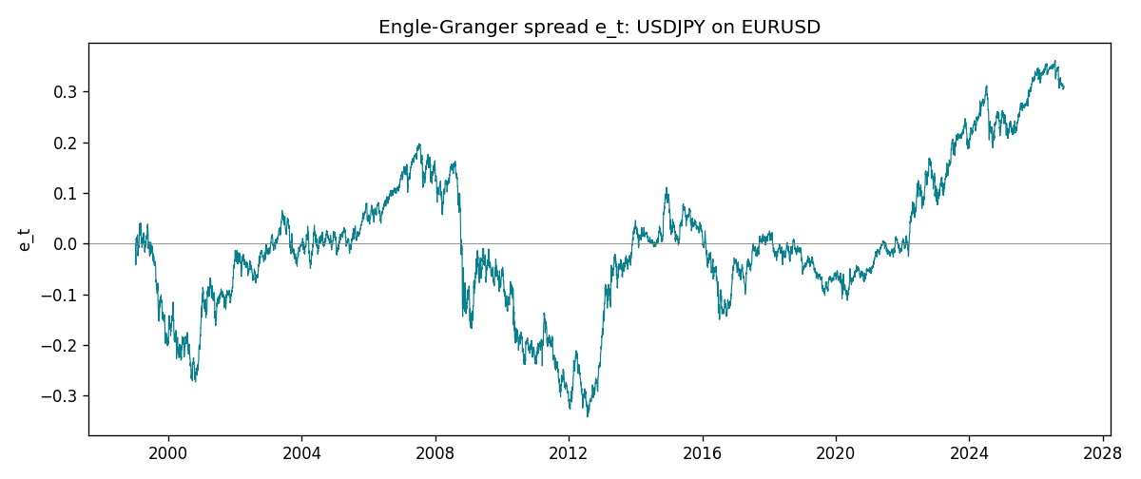
Daily log returns
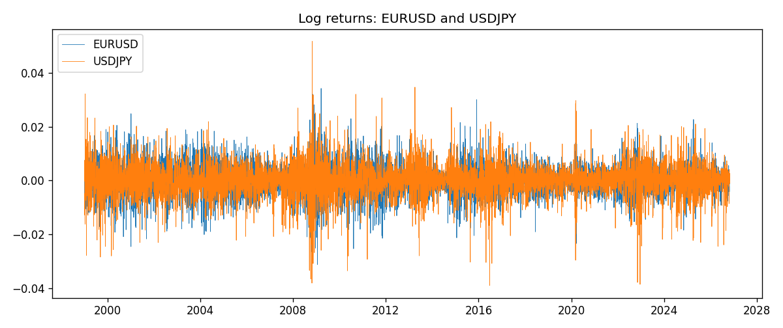

Data report
Matched rows are in the sibling Excel workbook named EURUSD-USDJPY_Coint_D1.xlsx. Embedding all rows as a Word table is impractical; this file holds column summaries and the first and last 15 matched rows.
Column summaries
column | count | mean | std | min | 25% | 50% | 75% | max
EURUSD_open | 7200 | 1.1812699 | 0.15089907 | 0.8272 | 1.086045 | 1.16609 | 1.2939325 | 1.5995
USDJPY_open | 7200 | 113.80877 | 19.206548 | 75.693 | 104.4225 | 110.983 | 120.69125 | 163.824
EURUSD_high | 7200 | 1.1864006 | 0.15149686 | 0.8326 | 1.0901575 | 1.17121 | 1.2991625 | 1.6038
USDJPY_high | 7200 | 114.3063 | 19.268128 | 76.001 | 104.878 | 111.441 | 121.26 | 163.978
EURUSD_low | 7200 | 1.1762568 | 0.15022122 | 0.8227 | 1.0819775 | 1.162475 | 1.288265 | 1.5865
USDJPY_low | 7200 | 113.28572 | 19.134551 | 75.402 | 103.8875 | 110.53 | 120.17 | 163.628
EURUSD_close | 7200 | 1.1813075 | 0.15087411 | 0.8267 | 1.085995 | 1.16602 | 1.2939425 | 1.5997
USDJPY_close | 7200 | 113.82186 | 19.221964 | 75.811 | 104.4165 | 111.023 | 120.6855 | 163.851
EURUSD_tick_volume | 7200 | 103020.56 | 173417.03 | 218 | 9398.5 | 52714 | 99443.25 | 1471626
USDJPY_tick_volume | 7200 | 106139.77 | 179306.98 | 149 | 9927.5 | 53095 | 92761 | 1803508
EURUSD_spread | 7200 | 19.389444 | 16.57873 | 0 | 8 | 12 | 30 | 50
USDJPY_spread | 7200 | 20.3175 | 17.636173 | 0 | 6 | 11 | 30 | 50
EURUSD_real_volume | 7200 | 4.0252061e+10 | 1.6676396e+11 | 0 | 0 | 0 | 0 | 3.6149665e+12
USDJPY_real_volume | 7200 | 3.4708591e+10 | 1.6077621e+11 | 0 | 0 | 0 | 0 | 3.8834203e+12
EURUSD_log_price | 7200 | 0.15836825 | 0.12910978 | -0.19031341 | 0.08249662 | 0.15359624 | 0.25769376 | 0.46981611
USDJPY_log_price | 7200 | 4.7205683 | 0.16778371 | 4.3282434 | 4.6483877 | 4.7097374 | 4.793188 | 5.0989575
EURUSD_log_return | 7200 | -1.012e-05 | 0.00580063 | -0.03123819 | -0.0032472 | 0 | 0.00325137 | 0.03433183
USDJPY_log_return | 7200 | 4.989e-05 | 0.00620383 | -0.03908203 | -0.00319719 | 0.00011638 | 0.00340925 | 0.05184024
spread_e | 7200 | 0 | 0.143094 | -0.34183834 | -0.07436389 | -0.01029047 | 0.07360987 | 0.36114733
ecm_fitted | 7199 | 4.992e-05 | 0.00023843 | -0.00238207 | -8.915e-05 | 4.444e-05 | 0.00017437 | 0.00207951
First 15 matched rows (selected columns)
time | EURUSD_log_price | USDJPY_log_price | spread_e | EURUSD_log_return | USDJPY_log_return
1999-01-05 | 0.16194877 | 4.7177843 | -0.00035434491 | -0.0048360507 | -0.00017868311
1999-01-06 | 0.1504008 | 4.7253503 | -0.00062441429 | -0.011547966 | 0.0075660159
1999-01-07 | 0.15802886 | 4.7124988 | -0.0082998338 | 0.0076280636 | -0.012851583
1999-01-08 | 0.14712606 | 4.7077268 | -0.020470119 | -0.010902799 | -0.0047719894
1999-01-11 | 0.14002278 | 4.6915314 | -0.041485607 | -0.007103287 | -0.016195423
1999-01-12 | 0.14453315 | 4.7238417 | -0.0061146468 | 0.0045103728 | 0.032310364
1999-01-13 | 0.1553785 | 4.731979 | 0.00938198 | 0.010845346 | 0.0081373171
1999-01-14 | 0.1553785 | 4.731979 | 0.00938198 | 0 | 0
1999-01-15 | 0.14522525 | 4.7375134 | 0.0080266487 | -0.010153245 | 0.0055343401
1999-01-18 | 0.14885095 | 4.737601 | 0.010574531 | 0.0036256946 | 8.7600193e-05
1999-01-19 | 0.14867859 | 4.731979 | 0.0048356362 | -0.00017235436 | -0.0056219403
1999-01-20 | 0.14548467 | 4.726591 | -0.0027196526 | -0.0031939256 | -0.0053879917
1999-01-21 | 0.14850621 | 4.7350574 | 0.0077970757 | 0.0030215416 | 0.0084664056
1999-01-22 | 0.14729869 | 4.7410987 | 0.013018946 | -0.0012075213 | 0.0060412564
1999-01-25 | 0.14427349 | 4.7337393 | 0.0036067262 | -0.0030251979 | -0.0073594164
Last 15 matched rows (selected columns)
time | EURUSD_log_price | USDJPY_log_price | spread_e | EURUSD_log_return | USDJPY_log_return
2026-10-13 | 0.11301614 | 5.0645236 | 0.31318074 | 0.0037402957 | -0.0018932826
2026-10-14 | 0.10925791 | 5.0645994 | 0.31070633 | -0.0037582255 | 7.5800166e-05
2026-10-15 | 0.11486322 | 5.0627469 | 0.31265748 | 0.0056053107 | -0.0018524319
2026-10-16 | 0.11663571 | 5.0623672 | 0.31348047 | 0.0017724895 | -0.00037976126
2026-10-19 | 0.11409625 | 5.0658618 | 0.31525196 | -0.0025394633 | 0.0034946841
2026-10-20 | 0.11648442 | 5.0636072 | 0.31461783 | 0.0023881672 | -0.0022546642
2026-10-21 | 0.11616395 | 5.0632783 | 0.31407154 | -0.00032046717 | -0.00032883504
2026-10-22 | 0.11456899 | 5.0546841 | 0.30439498 | -0.0015949606 | -0.0085942669
2026-10-23 | 0.11323047 | 5.0550349 | 0.30383751 | -0.001338521 | 0.00035080446
2026-10-26 | 0.11095981 | 5.0591588 | 0.30642058 | -0.0022706559 | 0.0041238746
2026-10-27 | 0.10680747 | 5.0619239 | 0.3063681 | -0.004152342 | 0.0027651658
2026-10-28 | 0.10903376 | 5.0609671 | 0.306922 | 0.0022262927 | -0.00095679538
2026-10-29 | 0.1112909 | 5.0605867 | 0.30807318 | 0.0022571351 | -0.00038043789
2026-10-30 | 0.11014505 | 5.059527 | 0.306236 | -0.0011458446 | -0.0010596481
2026-11-02 | 0.11226562 | 5.0621709 | 0.3103188 | 0.002120569 | 0.0026438521

